**PROJECT REPORT**

**Used Book Website**

***For***

***Amrita University (India)***

**by**

**Sreerag Sreenivasan (820911878)**

*Under the guidance of*

Dr. Carl Eckberg

Graduate Advisor, Dept. of Computer Science



**Department of Computer Science**

**San Diego State University**

**San Diego, CA, 92115**

**2018**

**SAN DIEGO STATE UNIVERSITY**

The Under Mentioned Evaluation Committee Approves the

Project by Sreerag Sreenivasan

**Used Book Website for Amrita University**

Dr. Carl Eckberg

Department of Computer Science

Dr. Roger Whitney, Graduate Advisor

Department of Computer Science

Dr. Xiaobai Liu, Professor

Department of Computer Science

**ACKNOWLEDGEMENT**

I express my sincere piece of gratitude to Dr. Carl Eckberg, Graduate Advisor, Department of Computer Science for his moral support, encouragement, suggestions to complete this project.

Furthermore, I would like to express my deep sense of gratitude to all the staff and faculties of Amrita University for having faith on me and giving me the permission to do this work as my capstone project.

I acknowledge the help of Prof. Krishnakumar Kalathil, Faculty, Department of Sociology, Amrita University for being a great force behind all my efforts through his advice, guidance, and encouraging nature throughout the course of the project.

Finally, I would like to express my gratitude towards my parents for their moral support for making this project a success.

**ABSTRACT**

The goal of this project is to develop first working prototype of a Used Book Website using advanced web technologies. It is aimed at students of Amrita University, India where they can purchase used books at a lesser price. Students can also submit their old book at the end of the semester to the library and the library officials finalizes a price for the book based on its condition. The book will be published in the used book website managed by the library. Students within the university will have access to the website and they can purchase it from there at the published price. The whole idea is a trial attempt by the university and if found successful, this project will be handed over to a commercial vendor and then they will operate on behalf of the library

The website will have 2 parts. One will be an admin portal to which only the library officials will have access. The other one will be the actual website that looks something like amazon.com, which we can call ‘store-front’. Only registered students of Amrita University will have access to ‘store-front’.

**TABLE OF CONTENTS**

[MOTIVATION 7](#_Toc511284144)

[HIGH LEVEL ARCHITECTURE DESIGN 8](#_Toc511284145)

[Traceability 9](#_Toc511284146)

[KEY MODULES AND THEIR USE CASES 10](#_Toc511284147)

[Admin -- Book Management Module 10](#_Toc511284148)

[Store-Front -- My Account Module 11](#_Toc511284149)

[Store-Front – Browse Book Module 12](#_Toc511284150)

[Store-Front – Shopping Cart Module 13](#_Toc511284151)

[DATA FLOW DIAGRAM 14](#_Toc511284152)

[ENTITY RELATIONSHIP MODEL 16](#_Toc511284153)

[SEQUENCE DIAGRAM 18](#_Toc511284154)

[TOOLS AND TECHNOLOGIES 20](#_Toc511284155)

[Angular 5 20](#_Toc511284156)

[TypeScript 20](#_Toc511284157)

[Sublime 21](#_Toc511284158)

[Angular CLI 21](#_Toc511284159)

[Java 8 21](#_Toc511284160)

[Spring Technologies 22](#_Toc511284161)

[Hibernate 23](#_Toc511284162)

[MySQL 23](#_Toc511284163)

[Angular Material 23](#_Toc511284164)

[Tomcat 24](#_Toc511284165)

[RESULT 25](#_Toc511284166)

[ADMIN PORTAL 25](#_Toc511284167)

[STORE-FRONT 26](#_Toc511284168)

[FUTURE WORK 29](#_Toc511284169)

[REFERENCES 30](#_Toc511284170)

**LIST OF FIGURES**

Figure 1: 3-tier architecture diagram 8

Figure 2: Admin Portal - Book Management Functionality 10

Figure 3: Store-Front - My Account Functionality 11

Figure 4: Store-Front - Browse Book Functionality 12

Figure 5: Store-Front - Shopping Cart Functionality 13

Figure 6: Data Flow Diagram 14

Figure 7: Order Confirmation-Email Template 15

Figure 8: Entity Relationship Model 16

Figure 9: Sequence Diagram 18

Figure 10: New User Registration Email Template 19

Figure 11: Admin Portal - Login Page 26

Figure 12: Admin Portal - View Book List 26

Figure 13: Admin Portal: Add Book List 27

Figure 14: Store Front: Home Page 27

Figure 15: Store Front: Book Search 28

Figure 16: Store Front: Book Detail Info 28

Figure 17: Store Front: Shopping Cart 29

Figure 18: Store Front: Checkout and Payment 29

Figure 19: Future work: Use case diagram 30

# MOTIVATION

It is a known fact that the price of undergraduate and graduate level textbooks are quite high. Some students completely relay on the library for text books. Those people who buy new textbook used to abandon them the end of the year/semester. The thought about having a used book website where students can sell and buy books came from this realization.

This platform managed by the library will help students to get rid of their old books for a good price as well buy books at a reduced price, sort of win-win situation. The plan is to implement this on a trial basis with a working prototype, if the response is good then improve the website with more features. The whole idea is a trial attempt by the university to help students. Seeing the response from the students, the university has plans for outsourcing this library’s role onto a commercial vendor for better collection of books and then take it from there. Because of this same reason the whole website will look more like an amazon website more than a typical library website. This makes more sense in a way as students are buying used books through this website.

To develop the website I was asked by Amrita University to use the most advanced web technologies and hence this application’s core technical components include Angular 5 for front-end and Java based back-end using couple of open-sourced Spring technology projects like Spring MVC, Spring Security, Spring Boot, Spring Data etc. On the Database side I am using MySQL and an ORM tool called Hibernate to map Java Objects to database.

The Amrita University officials are more concerned about the core functionality of the web application than the CSS part of it. So I am using a CSS package just for the demo purpose which I will remove when I handover the project to them. Their internal IT team will work on it with some tweets to bring it to their standards.

# HIGH LEVEL ARCHITECTURE DESIGN

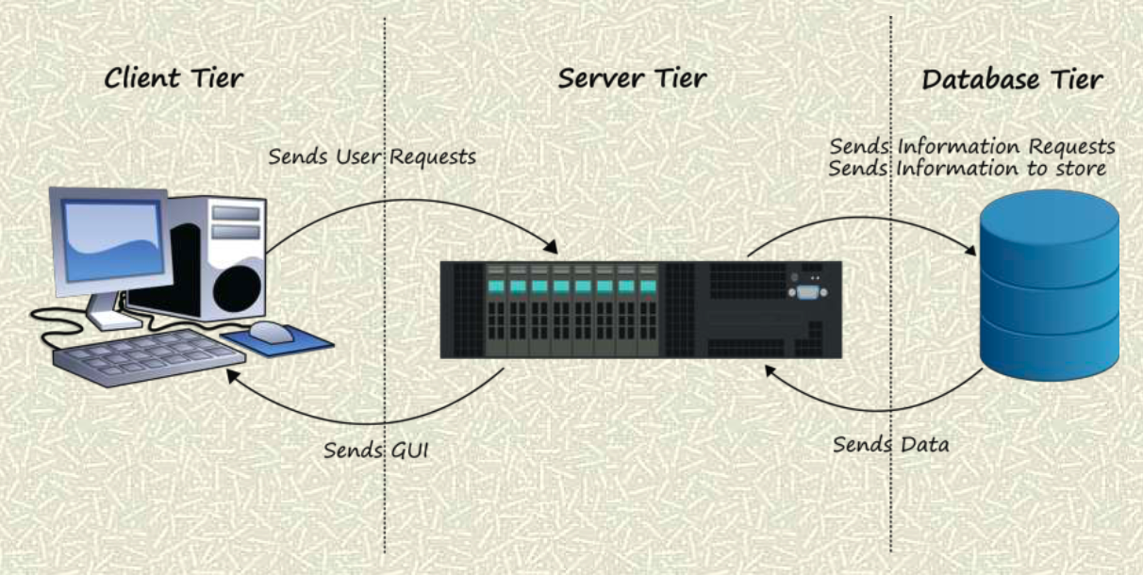

Figure 1: 3-tier architecture diagram

The project uses a 3 tier architecture. Three-tier architecture is a client–server software architecture pattern in which the user interface (presentation), functional process logic ("business rules"), computer data storage and data access are developed and maintained as independent modules, most often on separate platforms

Apart from the usual advantages of modular software with well-defined interfaces, the three-tier architecture is intended to allow any of the three tiers to be upgraded or replaced independently in response to changes in requirements or technology. For example, a change of operating system in the *presentation tier* would only affect the user interface code.

In the web development field, three-tier is often used to refer to websites, commonly electronic commerce websites, which are built using three tiers:

1. A front-end web server serving static content, and potentially some cached dynamic content. In web-based application, front end is the content rendered by the browser. The content may be static or generated dynamically.
2. A middle dynamic content processing and generation level application server (e.g., Symfony, Spring, ASP.NET, Django, Rails).
3. A back-end database or data store, comprising both data sets and the database management system software that manages and provides access to the data.

## Traceability

The end-to-end traceability of data flows through *n*-tier systems is a challenging task which becomes more important when systems increase in complexity. The Application Response Measurement defines concepts and APIs for measuring performance and correlating transactions between tiers. Generally, the term "tiers" is used to describe physical distribution of components of a system on separate servers, computers, or networks (processing nodes). A three-tier architecture then will have three processing nodes. The term "layers" refer to a logical grouping of components which may or may not be physically located on one processing node.

3-Tier Architecture provides the following benefits.

* **Scalability**—Each tier can scale horizontally. For example, you can load-balance the Presentation tier among 3 servers to satisfy more Web requests without adding servers to the Application and Data tiers.
* **Performance**—Because the Presentation tier can cache requests, network utilization is minimized, and the load is reduced on the Application and Data tiers. If needed, you can load-balance any tier.
* **Availability**—If the Application tier server is down and caching is sufficient, the Presentation tier can process Web requests using the cache.

No Architecture design is perfect and hence it has its limitations also

* You must manually push templates, assets, private assets, uploaded images, and uploaded files from the Application tier to the Presentation tier. You may use a tool like Robocopy to do this.
* You create content (HTML, assets, Page Builder pages, and so on) only in the Application tier. You can only view content from Presentation tier.
* Because 3-Tier Architecture uses WCF, it requires:
  + the 8.5 or higher Framework API and databinding. You cannot use API calls outside of the Framework API.
  + templated server controls.
  + *widget*s created by the Framework API.
* Because the business logic executes on the Application tier, its Web site directory must be identical to the Presentation tier's.

# KEY MODULES AND THEIR USE CASES

## Admin -- Book Management Module

**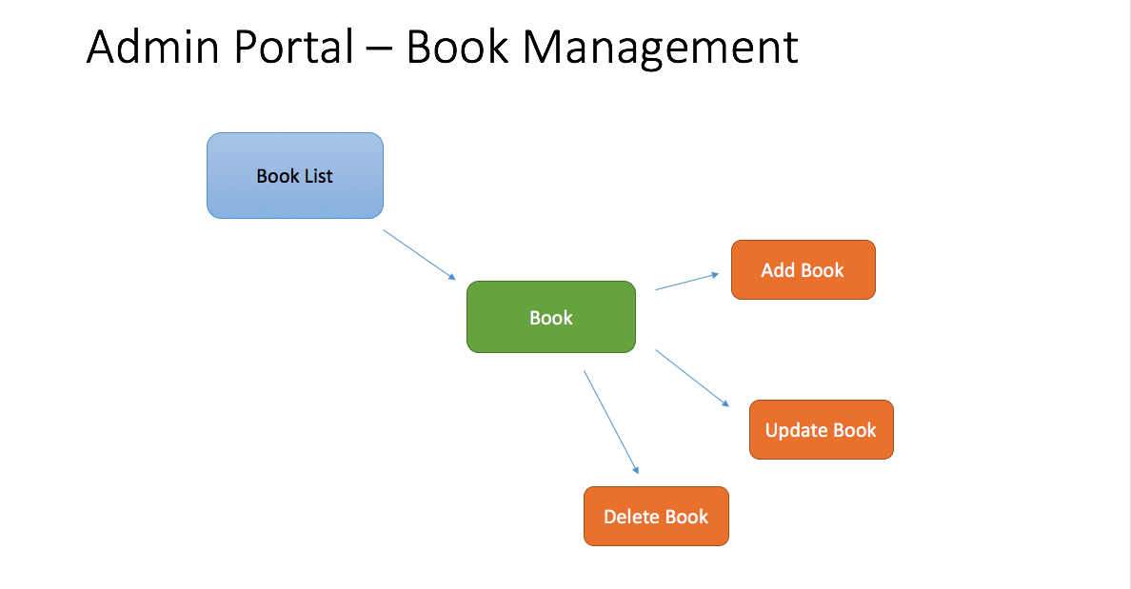**

Figure 2: Admin Portal - Book Management Functionality

The Admin Module is a portal for library associates and is going to be simple which list all the books available in collection. There will be an authentication to verify if the admin portal user is an authorized user. Through the admin portal, user can add a new book to the database, edit details of an existing book and delete particular book from the database etc. In the implementation point also it is fairly simple. The most challenging part will be handling the session management and performing group operations.

Special technique should be implemented to ensure that both asynchronous and synchronous operations run to completion. Scenarios like database getting busy at times, system failure etc.. should keep all the incoming requests in a queue and process them once the system is back to normal condition.

System should be scalable as there is a possibility that library officials may have to assign admin privileges to some users and other restricted privileges to some other users. Though it is not required for now, it has been requested to consider this as well in the design especially when designing the database.

Below are the details of the different modules in the store-front.

## Store-Front -- My Account Module

**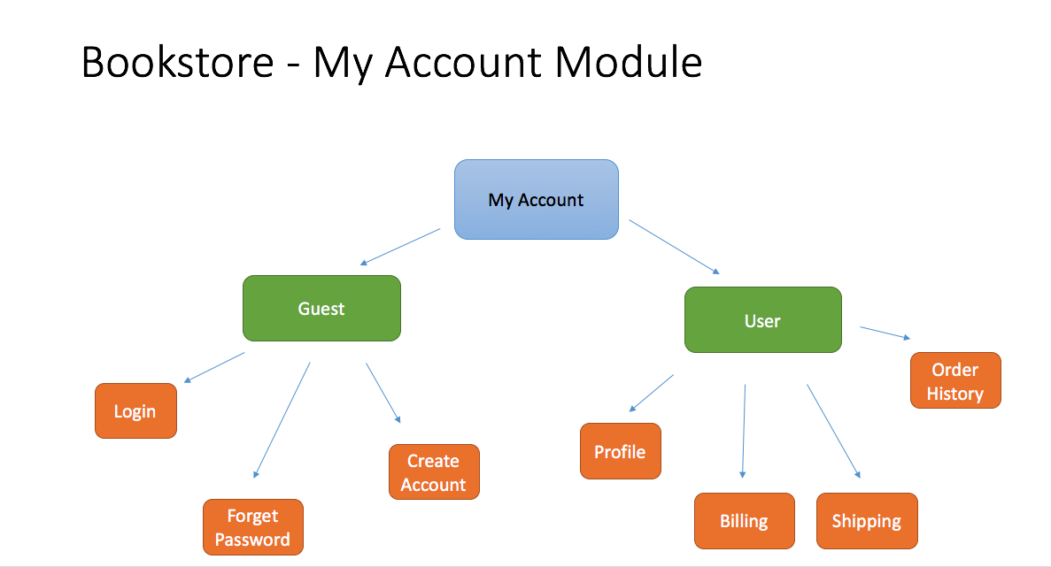**

Figure 3: Store-Front - My Account Functionality

The Store Front is divided into 3 functional modules namely My Account, Browse book and Shopping Cart starting with the my account module. Students of Amrita University can register themselves in used book website’s store-front and create an account. They can browse through the books as a guest user as well. But to make a purchase they have to create an account. Some of the other use cases for the guest user can creating an account, logging in to his already registered account and Resetting his password with the forgot password option. Once the a user is logged in to his account, he will have options to update his personal info in the profile section of the website. The user will also have options to save a default billing address, shipping address which will be preloaded when he places an order for the next time. This feature saves time and adds as a convenience feature for the user. A history of all the orders placed by the user is past is maintained in the system and the user will have the option to view this history data through his profile.

In the UI perspective, under my account section, the first tab will be for account information like username, password, change password etc. The next tab is going to be shipping address, there will be 2 sub-tabs under shipping tab, one that lists the already saved shipping addresses. User can set any of these addresses as default address. The second sub tab under shipping gives option to enter a new shipping address. User can delete any of the saved addresses from the first sub-tab under shipping. The next main tab will be payment with functionality similar to shipping address tab. The order history tab simply lists all previous order , upon clicking any order user can see full order details.

## Store-Front – Browse Book Module

**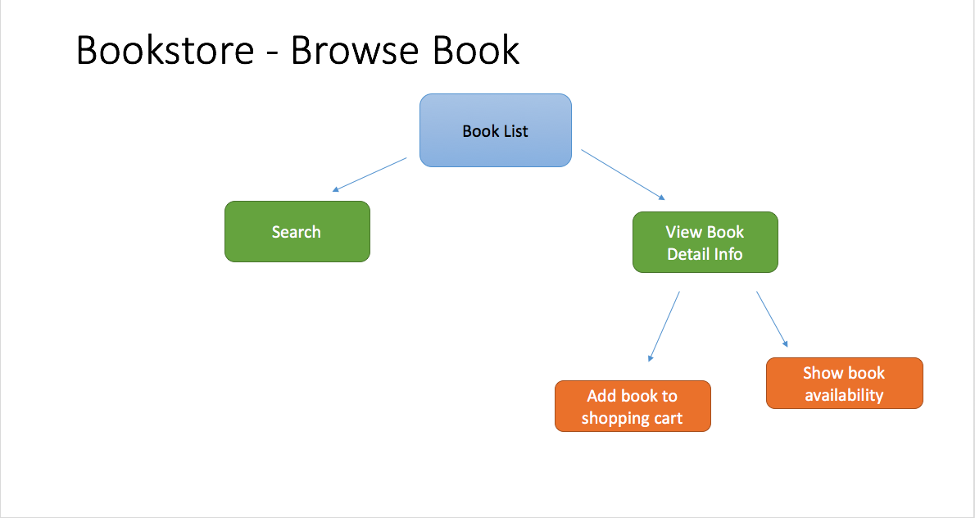**

Figure 4: Store-Front - Browse Book Functionality

Browsing book details is a common option available for Guest users as well as registered users. The is a Book Title pattern search implemented to make things easy. The result of the search as well as normal listing of books will give a snapshot about the book’s info like Title, Author and Price. If the user wants to see more info about the book, he/she can click on the book and it will display the detailed book info. User can add the book to his cart at this point and continue the shopping or do a checkout.

The search functionality here should implement real-time search functionality with title of the book, meaning as you type in the filter the corresponding search result should be displayed. Within the search result to do some further filtering there should be dynamic filters option. That is category, year of publication and author will be some of the popular options for filtering and the available values in these filters should change dynamically based on the search result. The implementation of dynamic filters is outside the scope of this project but there should be provision to do it. The implementation part of it is done by the IT team of Amrita University. It has been decided this way to give an opportunity for the IT team to get familiarized with the code base of the project as they will be supporting this website after it’s been put into use.

## Store-Front – Shopping Cart Module

**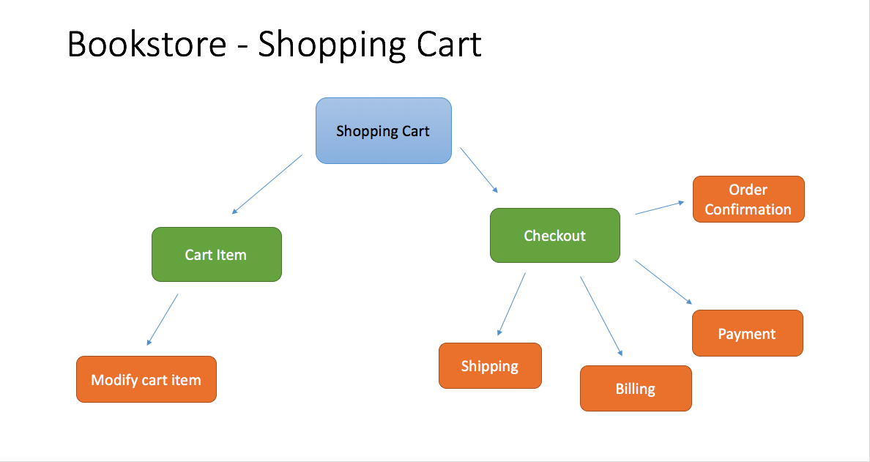**

Figure 5: Store-Front - Shopping Cart Functionality

The module with the most functionality is the Shopping cart module. The functionality in this module starts from the point where the users adds a book to his cart. He will have the option of editing this cart item at any point of time such as removing the item from the cart, increasing the quantity of purchase etc. We will have to validate it against the available stock each time if he increases the number of items for purchase. The checkout option enable the user to take all the items in his cart for billing. If the user has already updated his personal information in his profile we need to take those and update them as the shipping, billing, payment details in this order. Of course the user can manually edit these fields as well. Once the user places the order an email should be send to the user’s email id confirming the order.

Multiple addition of a book to the cart should only increase the quantity of the book meaning there should not be duplicate entries in the cart at any point of time. If the user ties to increase the quantity of the book more that the available stock system should through an error. If the available stock is less than 5 then that should highlighted against the inventory both during addition to the cart and during checkout time. The total cost should be updated automatically when the purchase quantity is updated in the cart. The checkout page should look more life amazon checkout page highlighting the total cost and discounts if any applicable.

# DATA FLOW DIAGRAM

A **data flow diagram** (**DFD**) is a graphical representation of the "flow" of data through an information system, modelling its process aspects. A DFD is often used as a preliminary step to create an overview of the system without going into detail, which can later be elaborated. DFDs can also be used for the visualization of data processing (structured design).

A DFD shows what kind of information will be input to and output from the system, how the data will advance through the system, and where the data will be stored. It does not show information about process timing or whether processes will operate in sequence or in parallel, unlike a traditional structured flowchart which focuses on control flow, or a UML activity workflow diagram, which presents both control and data flows as a unified model

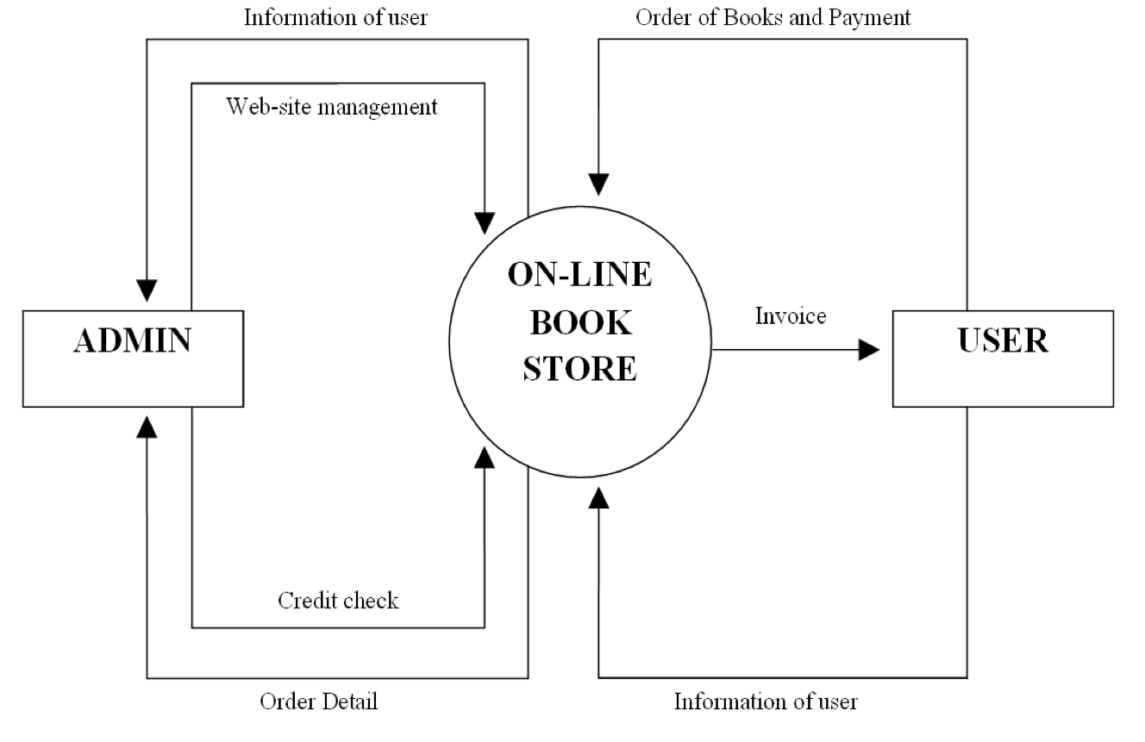

Figure 6: Data Flow Diagram

As you could imagine the admin portal and the store-front will be interacting with the same database. The Admin portal will have the website management privileges and there will be only one authorized user who has access to the admin portal. If there is a need for creating another user with admin privileges that has to be done through the backend. It has been decided to keep the functionality like this because the need for having a second user with admin privileges is very less. The normal user(Customer) interacts only through the store front and that’s how he can place order for a book and do the payment. The payment done through the front will be credited to the admin’s account and the customer will get order confirmation invoice. The order placed by the user should update the available stock information in the database. Since admin portal uses the same database, admin will see the updated values when the he logs in.

The email template which is send after order confirmation should look professional and should be in the form as mentioned below.

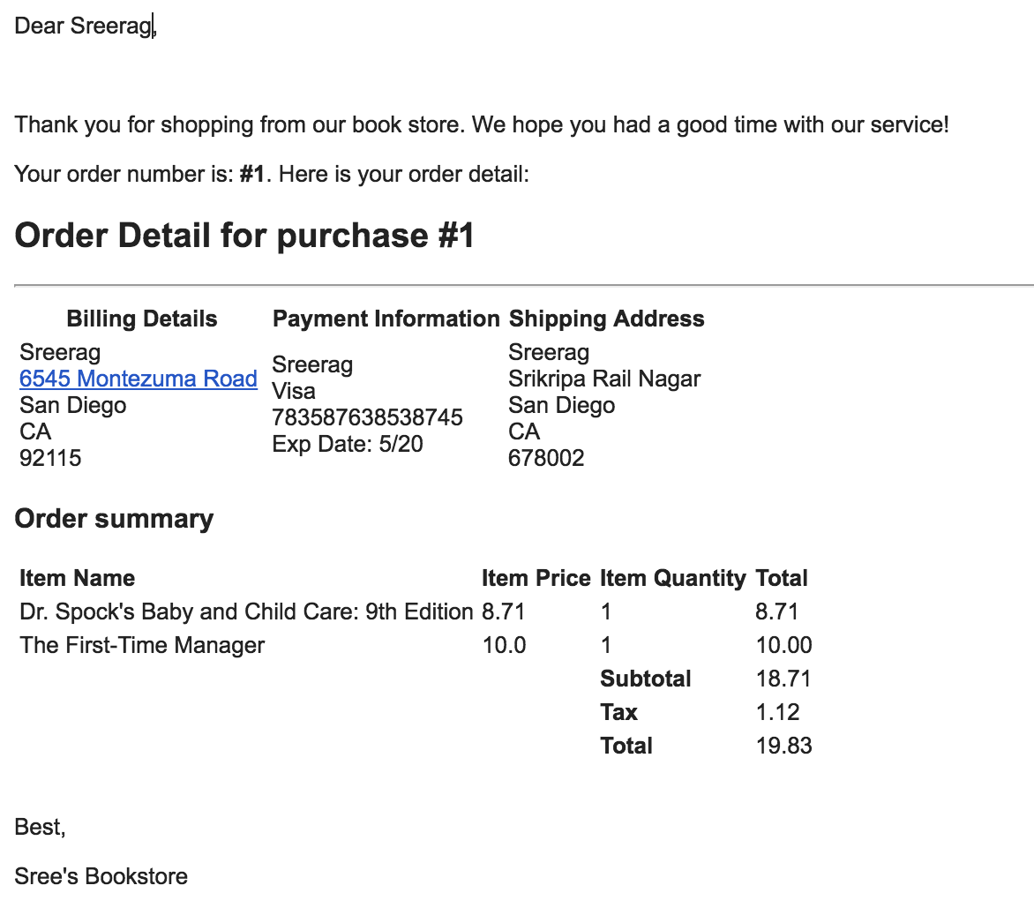

Figure 7: Order Confirmation-Email Template

# ../Pics/Database_model.pngENTITY RELATIONSHIP MODEL

Figure 8: Entity Relationship Model

An **entity–relationship model** (**ER model** for short) describes interrelated things of interest in a specific domain of knowledge. A basic ER model is composed of entity types (which classify the things of interest) and specifies relationships that can exist between instances of those entity types

In software engineering, an ER model is commonly formed to represent things that a business needs to remember in order to perform business processes. Consequently, the ER model becomes an abstract data model, that defines a data or information structure which can be implemented in a database, typically a relational database.

Entity Relationship model diagramed above is self-explanatory. The reason for finalizing such a model is mainly because of 2 reasons.

1. To make the database tables compatible with the java pojo classes, this is necessary because the proposal is to use ORM (Object Relation Mapping) tool to perform CURD operations in the database.
2. There are certain functionalities that are outside the scope of this first prototype but there is a request to leave provision for these functionalities in the database.

# SEQUENCE DIAGRAM

A sequence diagram shows object interactions arranged in time sequence. It depicts the objects and classes involved in the scenario and the sequence of messages exchanged between the objects with use case realizations in the Logical View of the system under development. Sequence diagrams are sometimes called **event diagrams** or **event scenarios**.

A sequence diagram shows, as parallel vertical lines (lifelines), different processes or objects that live simultaneously, and, as horizontal arrows, the messages exchanged between them, in the order in which they occur. This allows the specification of simple runtime scenarios in a graphical manner.

**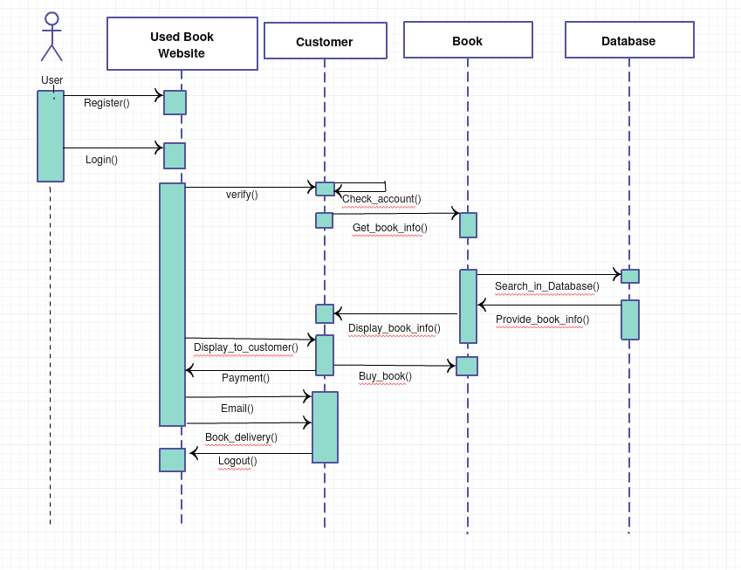**

Figure 9: Sequence Diagram

Since the sequence diagram for the admin portal shares login functionality with store-front. It does not make much sense to make a separate sequence diagram for admin portal. The above diagram shows a register method that enables the user to register in the store-front. Once registered he can login to the website to make purchases. Once he login, in the backend we verify his account. When we makes a search for a book we make a call to the database to fetch the books information. This information is brought back to the website and displayed to the user. Once he decides to buy a book, the cart operation managed within the website itself but when he makes a payment the details are updated in the database with a call to the backend. An email is send out to the customer as well. The main use of customer as a separate entity in the sequence diagram is to show when does the book reach the customer’s hand and when he gets confirmation about certain things in the whole process.

For new user registration, we should verify the user’s email id is genuine. Rather than sending email with a verification link, a more simple buy intuitive way is to send a random system generated password to the user’s email id. The newly registered user should be allowed to login to his profile only with this the emailed password. He can change this password using my account module any time after the first login. The email template for the newly registered user with password is kept very simple for the time being this will be modified by IT team of Amrita University.

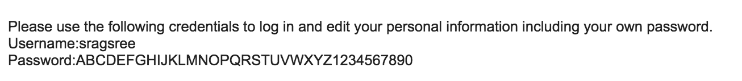

Figure 10: New User Registration Email Template

The order confirmation email template has already been mentioned in the previous section. If the stock of a particular book goes below a particular number say 5, system will automatically send an email to the admin just to give him an heads up information. He can check with availability of more used books and update the stock. The checkout screen will have shipping address, billing address and payment information as mentioned earlier. The final saving to the database happens only when the order has been saved successfully, If a user comes till the checkout and enters all these information and logout without placing the order his order information will be lost but his cart items will be saved and he can come later on and do the cart checkout.

# TOOLS AND TECHNOLOGIES

## Angular 5

Angular is a platform that makes it easy to build applications with the web. Angular combines declarative templates, dependency injection, end to end tooling, and integrated best practices to solve development challenges. Angular empowers developers to build applications that live on the web, mobile, or the desktop [1].

.



## TypeScript

**TypeScript** is an [open-source](https://en.wikipedia.org/wiki/Open-source_software) [programming language](https://en.wikipedia.org/wiki/Programming_language) developed and maintained by [Microsoft](https://en.wikipedia.org/wiki/Microsoft). It is a strict syntactical [superset](https://en.wikipedia.org/wiki/Superset) of [JavaScript](https://en.wikipedia.org/wiki/JavaScript), and adds optional static typing to the language. TypeScript is designed for development of large applications and [transpile](https://en.wikipedia.org/wiki/Source-to-source_compiler) to JavaScript.[[9]](https://en.wikipedia.org/wiki/TypeScript#cite_note-9) As TypeScript is a superset of JavaScript, existing JavaScript programs are also valid TypeScript programs [2].

.



## Sublime

**Sublime Text** is a proprietary cross-platform source code editor with a Python application programming interface(API). It natively supports many programming languages and markup languages, and functions can be added by users with plugins, typically community-built and maintained under free-software licenses [3].



## Angular CLI

The Angular CLI makes it easy to create an application that already works, right out of the box. It already follows our best practices. It can generate components, routes, services and pipes with a simple command. The CLI will also create simple test shells for all of these. It has features to easily test your app locally while developing [4].



## Java 8

**Java** is a general-purpose computer-programming language that is concurrent, class-based, object-oriented, and specifically designed to have as few implementation dependencies as possible. It is intended to let application developers "write once, run anywhere" (WORA). Java 8 is the latest iteration of Java released by Oracle during the development of this project [5].



Spring Technologies (Spring Data + Spring Security + Spring Boot)

The **Spring Framework** is an application framework and inversion of control container for the Java platform. The framework's core features can be used by any Java application, but there are extensions for building web applications on top of the Java EE (Enterprise Edition) platform [6].

Spring Boot is Spring's convention-over-configuration solution for creating stand-alone, production-grade Spring-based Applications that you can "just run" [6].

Spring's data access framework addresses common difficulties developers face when working with databases in applications. Support is provided for all popular data access frameworks in Java [6].

**Spring Security** is a Java/Java EE framework that provides authentication, authorization and other security features for enterprise applications [6].

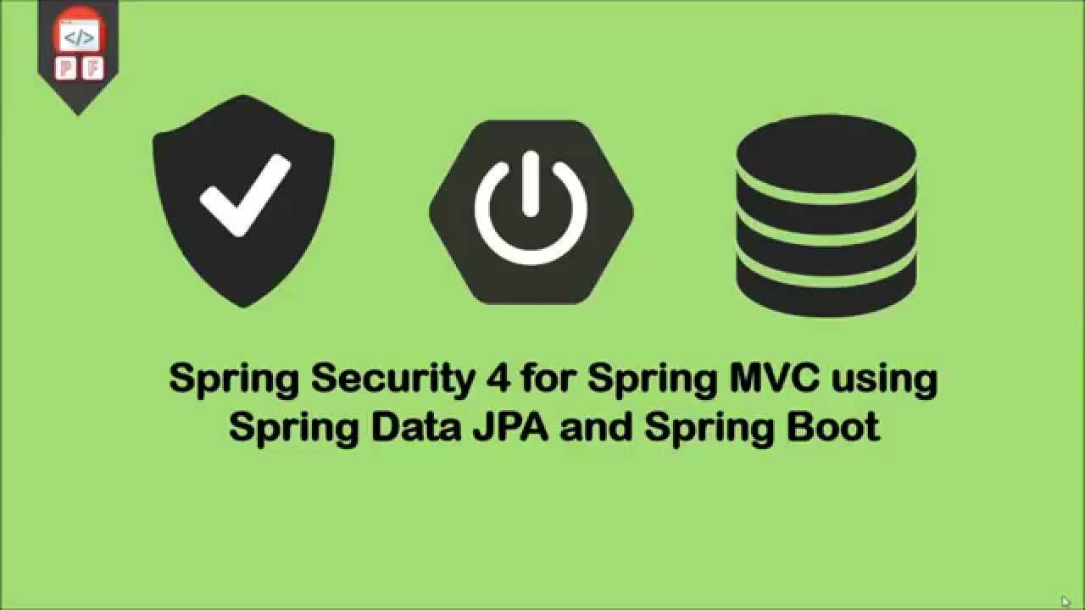

## Hibernate

**Hibernate ORM** (Hibernate in short) is an object-relational mapping tool for the Java programming language. It provides a framework for mapping an object-oriented domain model to a relational database. Hibernate handles object-relational impedance mismatch problems by replacing direct, persistent database accesses with high-level object handling functions [7].



## MySQL

**MySQL** is an open-source relational database management system (RDBMS). Its name is a combination of "My", the name of co-founder Michael Widenius's daughter, and "SQL", the abbreviation for Structured Query Language. The MySQL development project has made its source code available under the terms of the GNU General Public License, as well as under a variety of proprietary agreements [8].



## Angular Material

**Material Design** (codenamed **Quantum Paper**) is a design language developed in 2014 by Google. Expanding upon the "card" motifs that debuted in Google Now, Material Design makes more liberal use of grid-based layouts, responsive animations and transitions, padding, and depth effects such as lighting and shadows. Material design integrated with Angular technology as a CSS theme is called Angular Material [9].

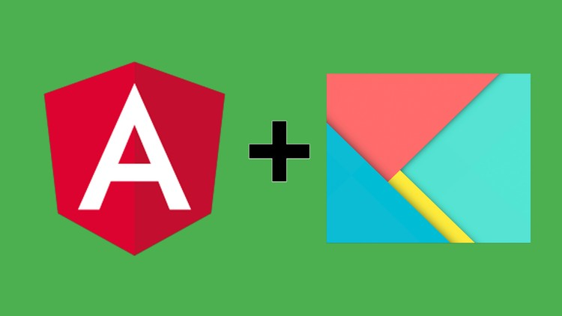

## Tomcat

**Apache Tomcat**, often referred to as **Tomcat Server**, is an open-source Java Servlet Container developed by the Apache Software Foundation (ASF). Tomcat implements several Java EE specifications including Java Servlet, JavaServer Pages (JSP), Java EL, and WebSocket, and provides a "pure Java" HTTP web server environment in which Java code can run [10].



# RESULT

## ADMIN PORTAL

*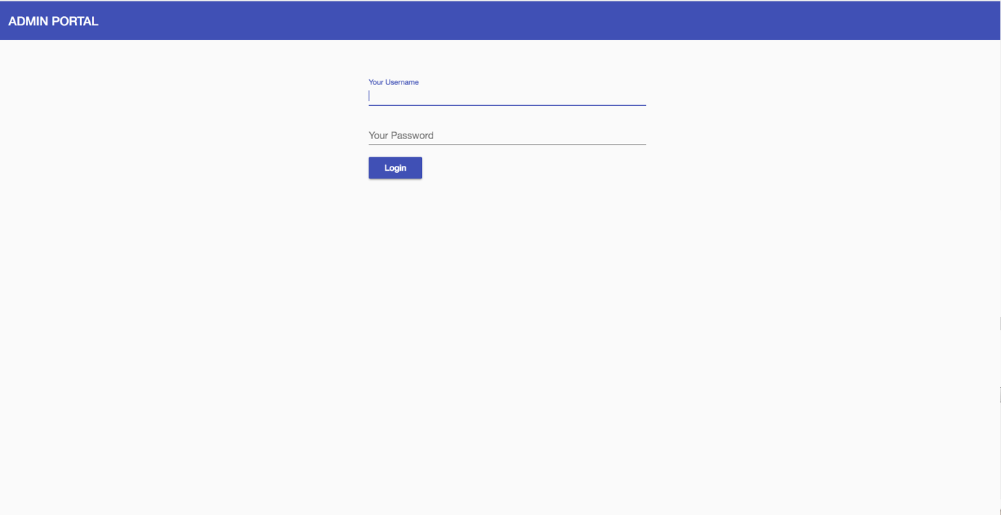*

Figure 11: Admin Portal - Login Page

*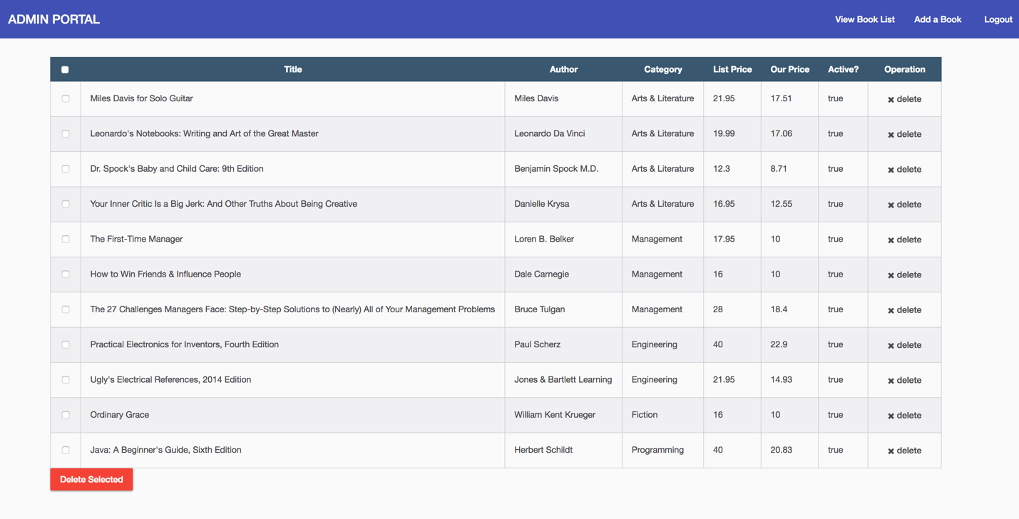*

Figure 12: Admin Portal - View Book List

*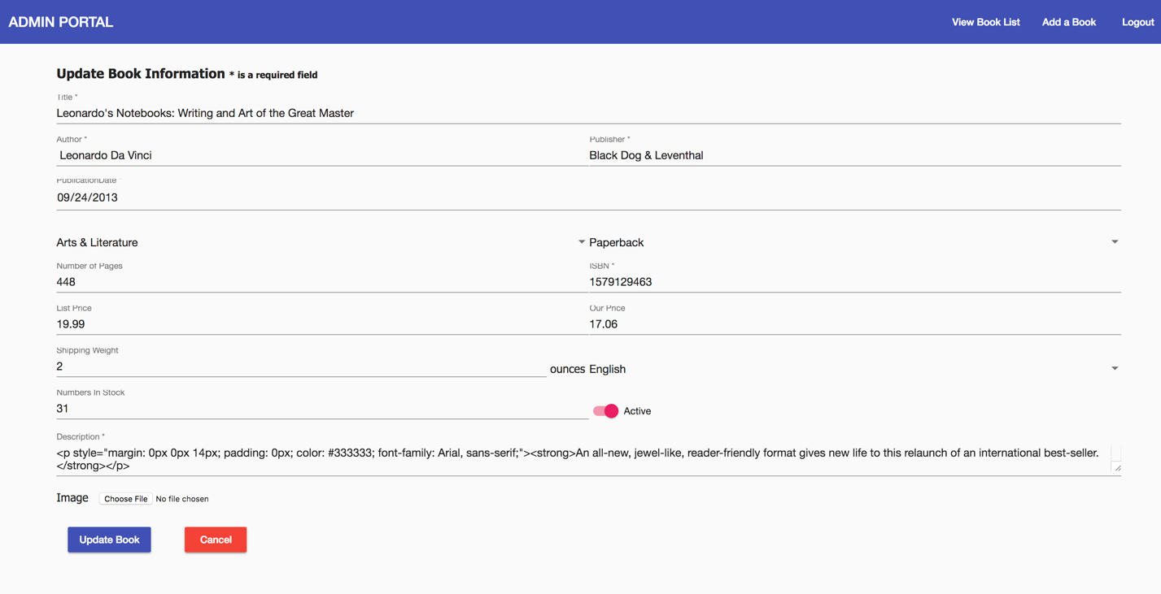*

Figure 13: Admin Portal: Add Book List

## STORE-FRONT

*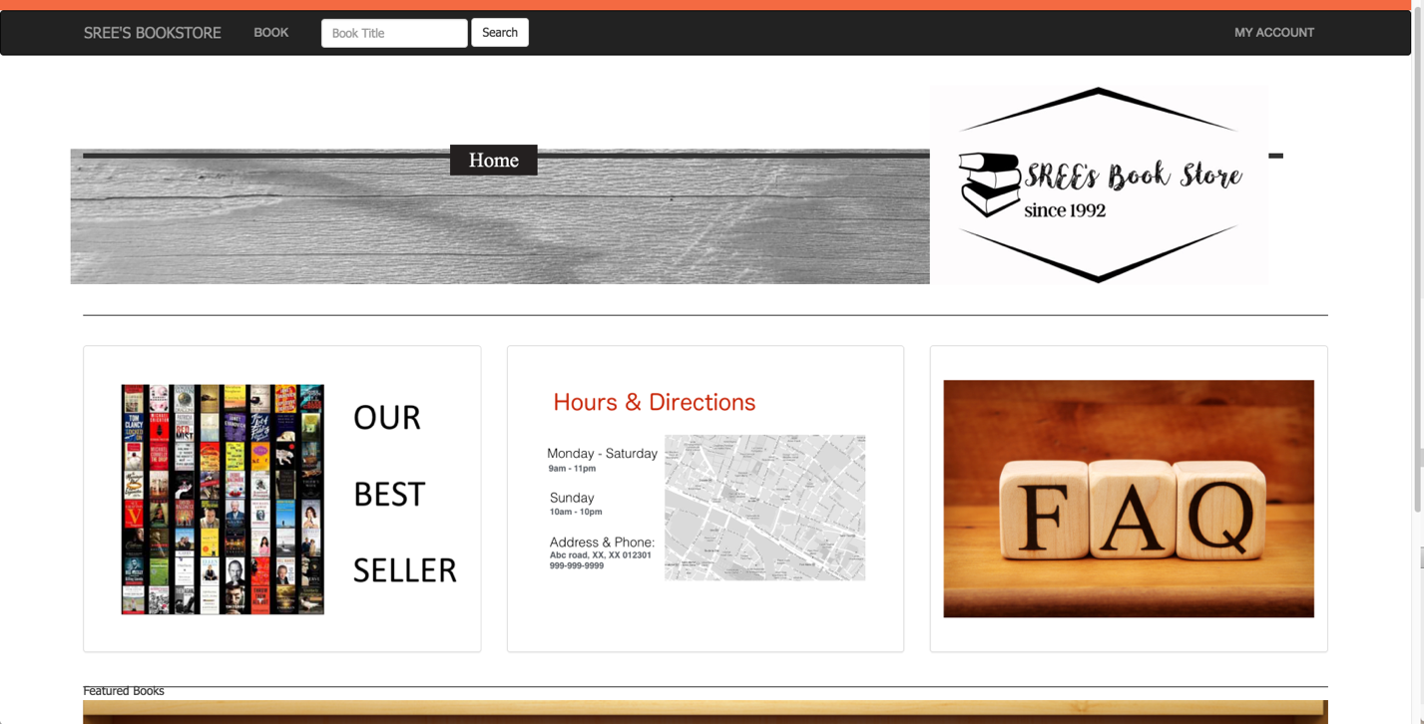*

Figure 14: Store Front: Home Page

*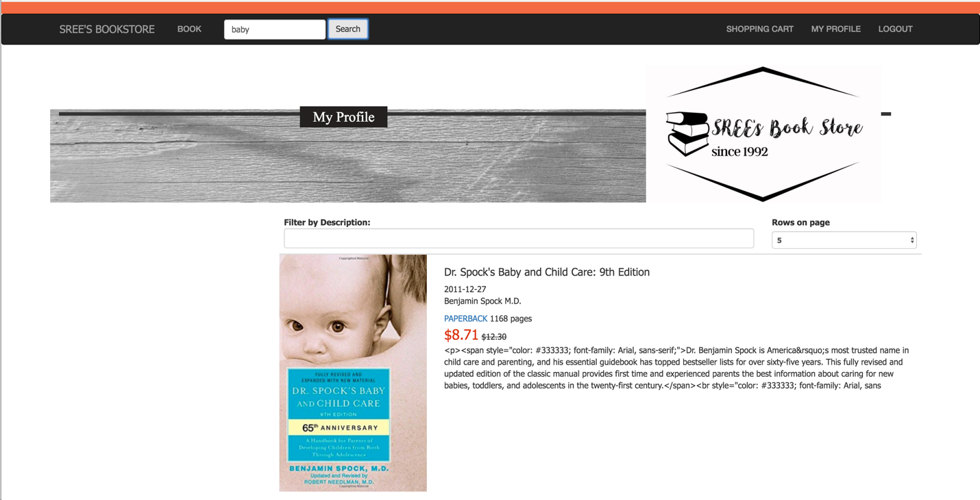*

Figure 15: Store Front: Book Search

*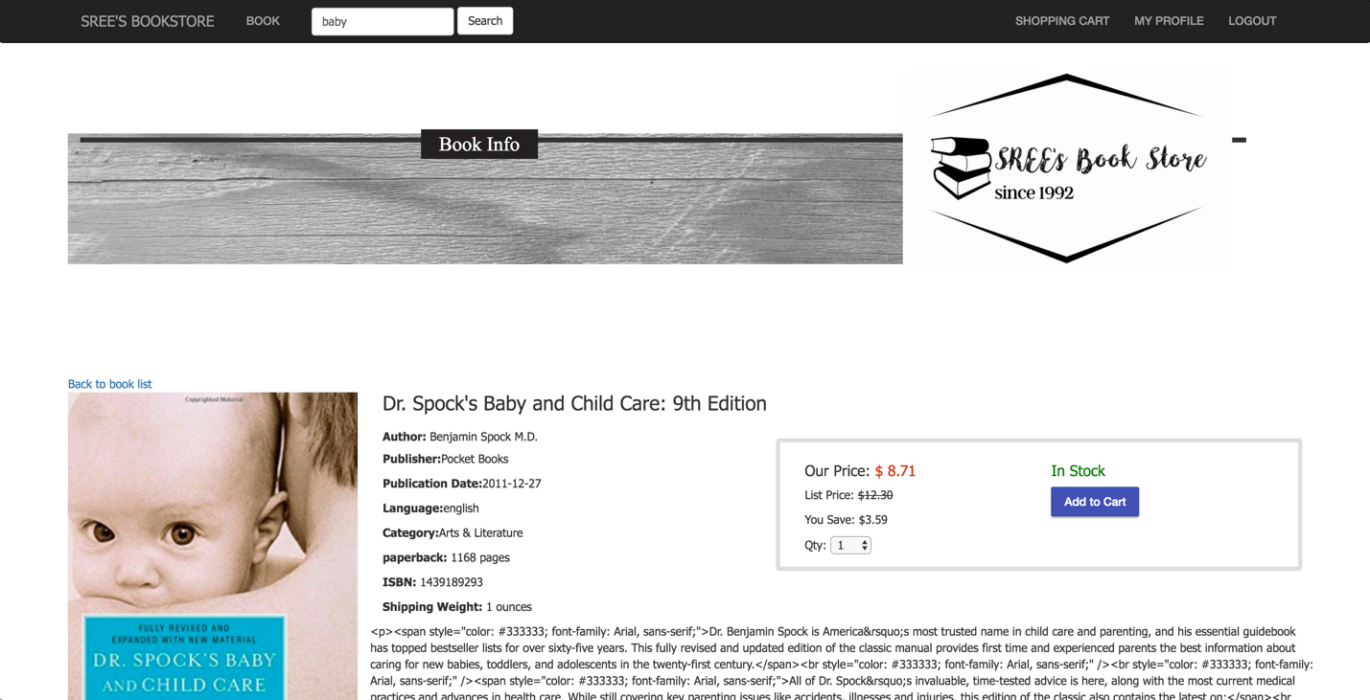*

Figure 16: Store Front: Book Detail Info

**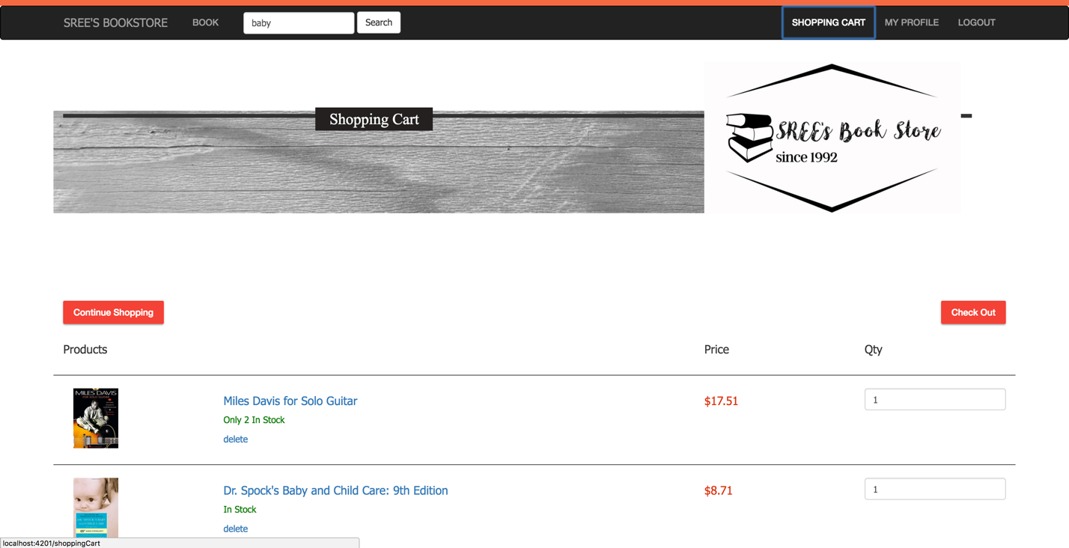**

Figure 17: Store Front: Shopping Cart

**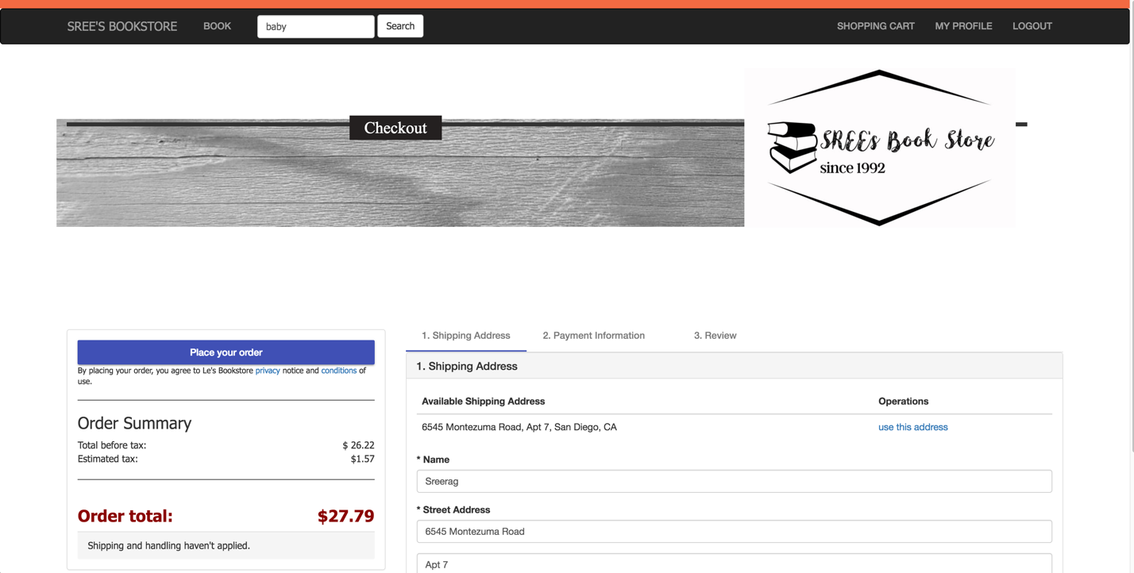**

Figure 18: Store Front: Checkout and Payment

# FUTURE WORK

The scope of this project is to build the first prototype, so obviously there are many ways to expand this project. Starting from the CSS, this project is to be handed over to IT team of Amrita University, they will port the theme of the project to their standard university theme. Functionalities like FAQ section and Featured book section are to be implemented by IT team.

Web scraping is another feature that is under consideration, rather than the library fixing the price for the book, when you update the book title, the condition and author information, The system will automatically check popular website and then fixes a price lesser than the actual price of the product published in these website. Since this is a feature that requires lot of effort, it’s been skipped from this prototype, The amrita university officials have also decided to implement this features only after considering the response from students for this initial version of the website.

Increasing the functionality of the store-front to the below use cases is also under discussion.

**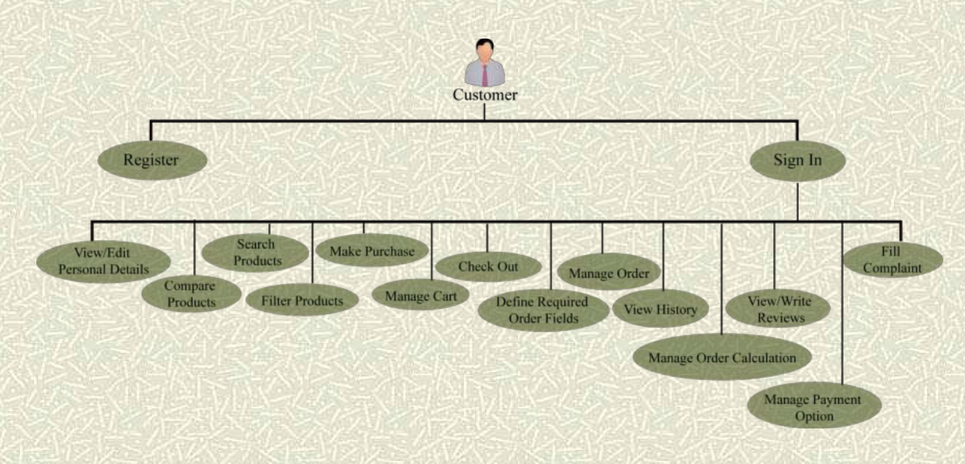**

Figure 19: Future work: Use case diagram

# REFERENCES

1. https://en.wikipedia.org/wiki/AngularJS
2. https://en.wikipedia.org/wiki/TypeScript
3. https://en.wikipedia.org/wiki/Sublime\_Text
4. https://cli.angular.io
5. https://en.wikipedia.org/wiki/Java\_(programming\_language)
6. https://en.wikipedia.org/wiki/Spring\_Framework
7. https://en.wikipedia.org/wiki/Hibernate\_(framework)
8. https://en.wikipedia.org/wiki/MySQL
9. https://en.wikipedia.org/wiki/Material\_Design
10. https://en.wikipedia.org/wiki/Apache\_Tomcat
11. https://stackoverflow.com
12. https://github.com